# **s o f i a**

# 

# **UX Document**

# 

# 

# 

# 

# 

# 

# 

# 

# 

# **Document Control**

# 

|  |  |  |
| --- | --- | --- |
| **Editor** | **Date** | **Update** |
| Lewis Thresh | 25/02/2015 | Created UX Design Documentation |
|  |  |  |
|  |  |  |

# 

# 

# Tasks to accomplish

* Icon style document
* Decide which icons to create (Including interacted icons)
* Decide how to handle different shapes
* Name all icons and “panes” etc
* Create annotated prototype

# Research

Research was conducted regarding the styling of our User Interface which included:

* Material Design (Google)
* Metro (Microsoft)
* Skeuomorphism (Apple)

Decided to use Material Design to it its simple, clean and most of all modern look. We also made a note that Apple has started to use a Material Design approach to their design, making Skeuomorphism look dated.

# Design

## Colour

# **Primary Scheme**

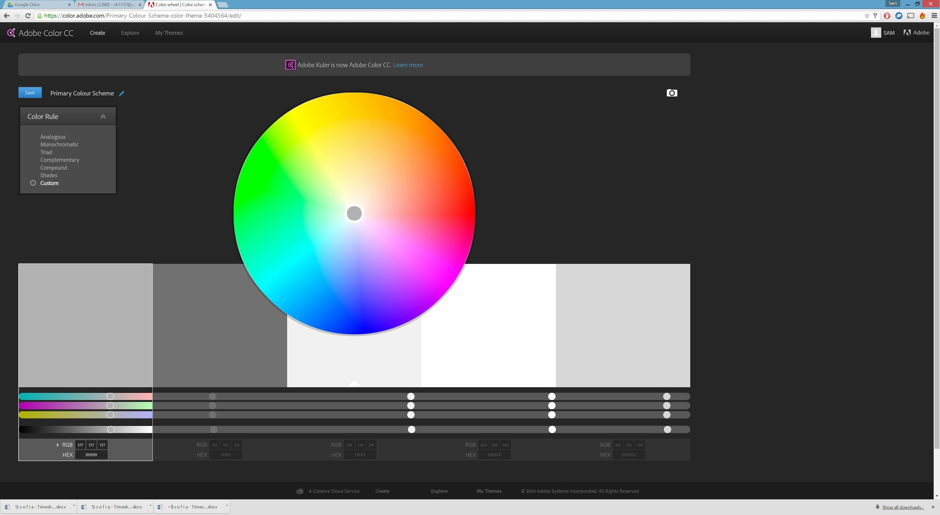

# **LearnEasy Scheme**

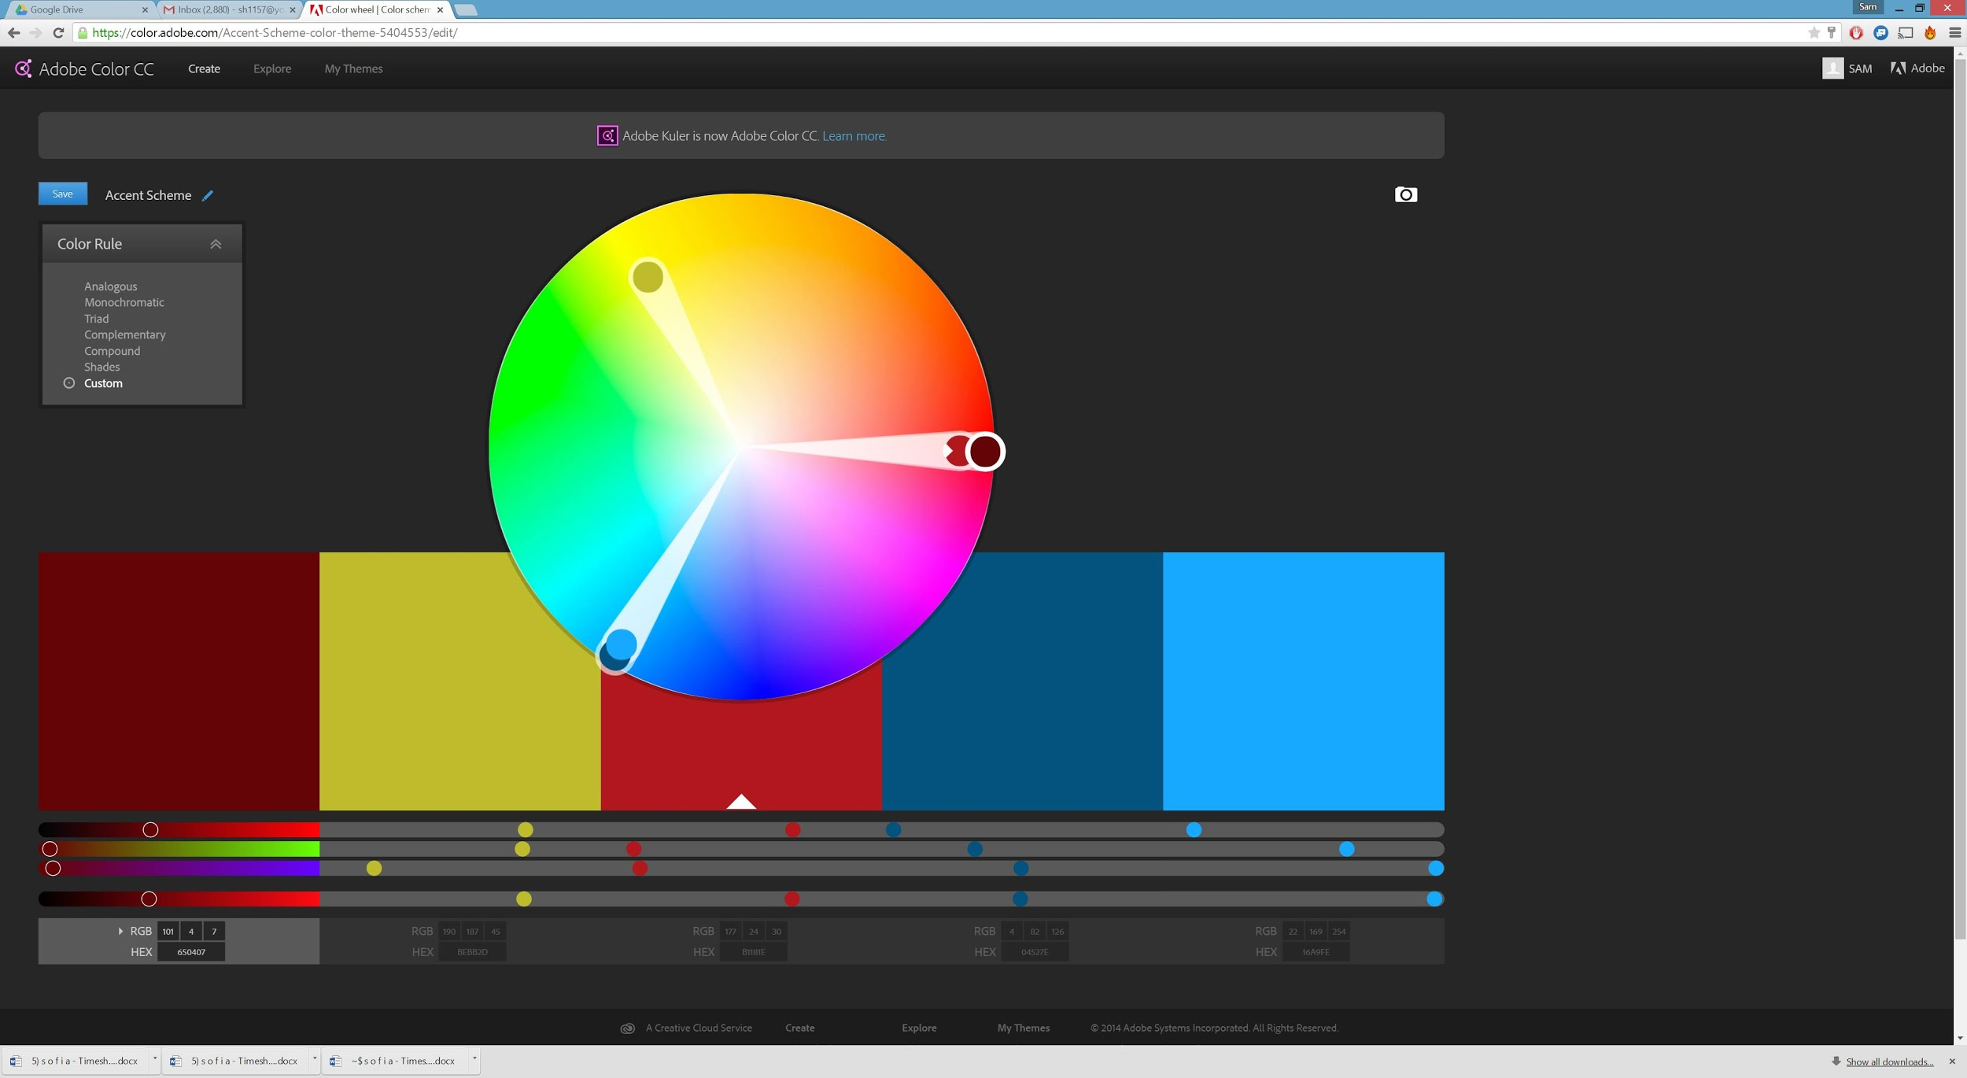

# **Accent Theme 1**

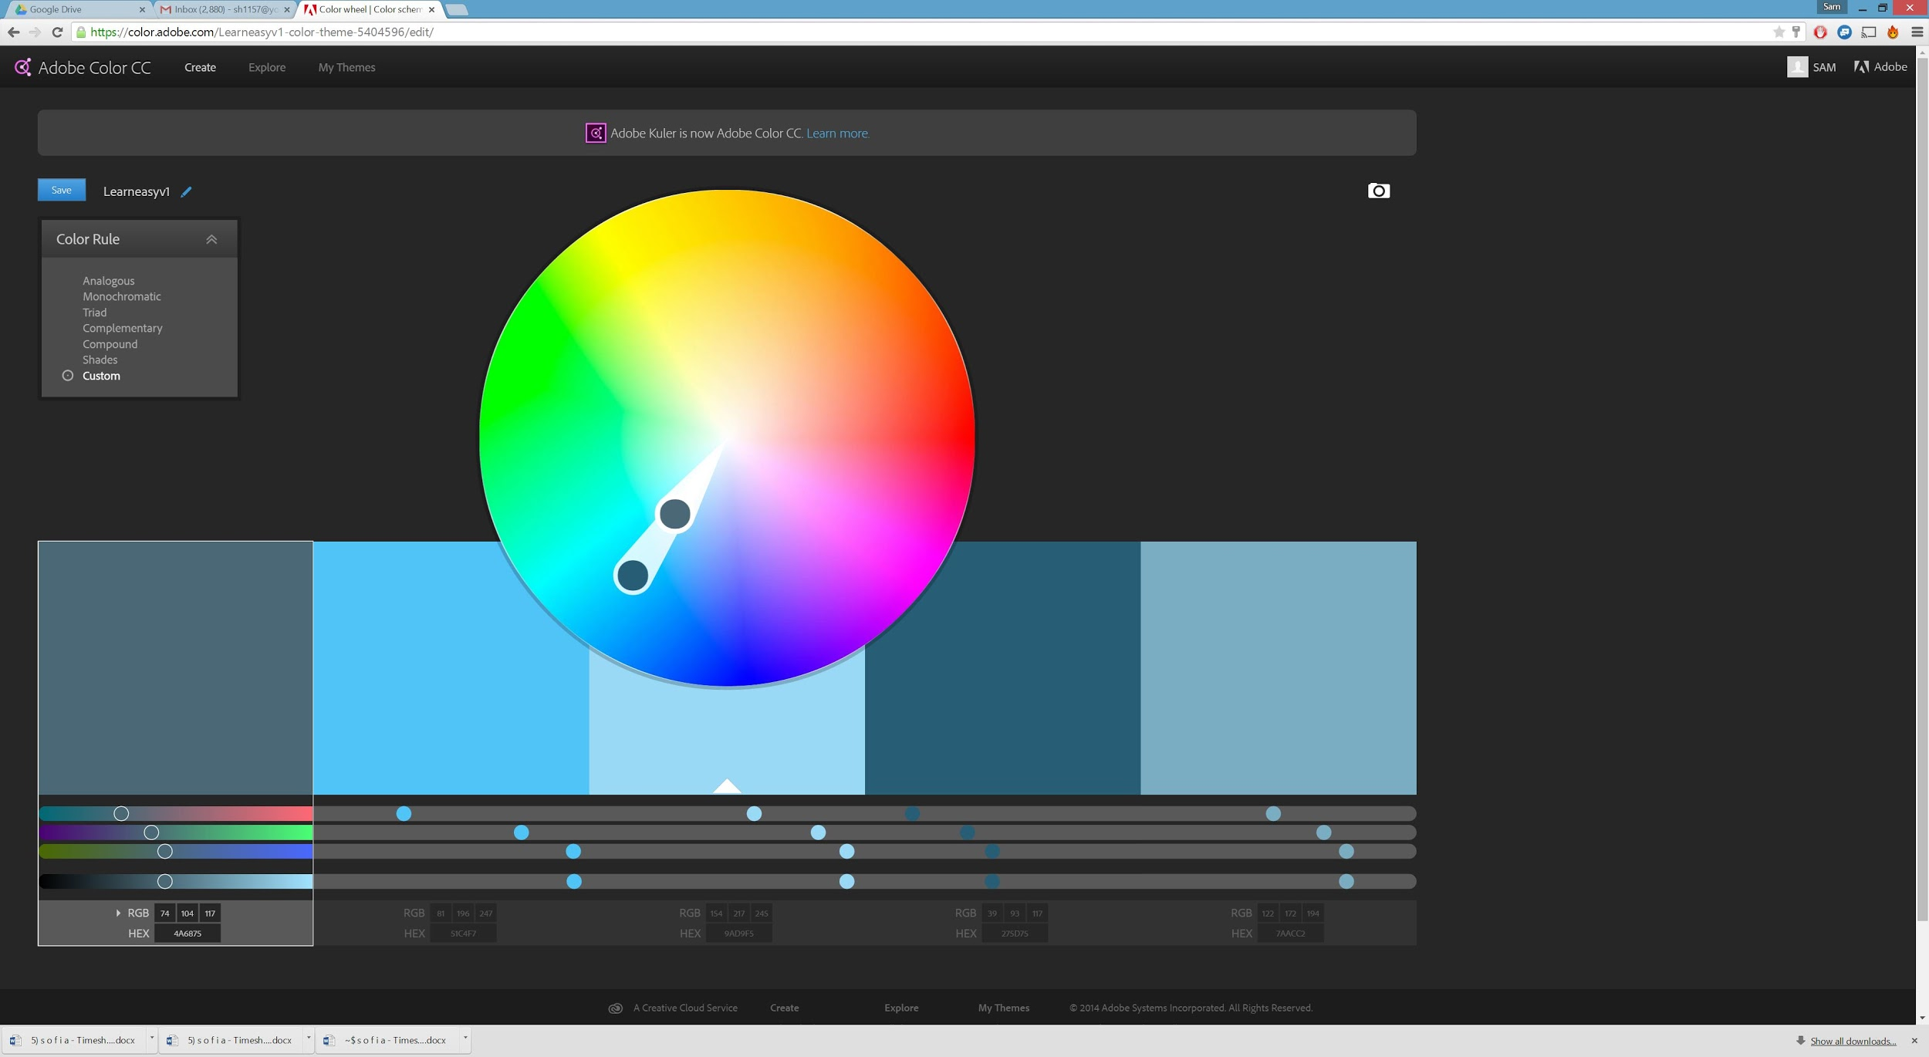

# **Accent Theme 2**

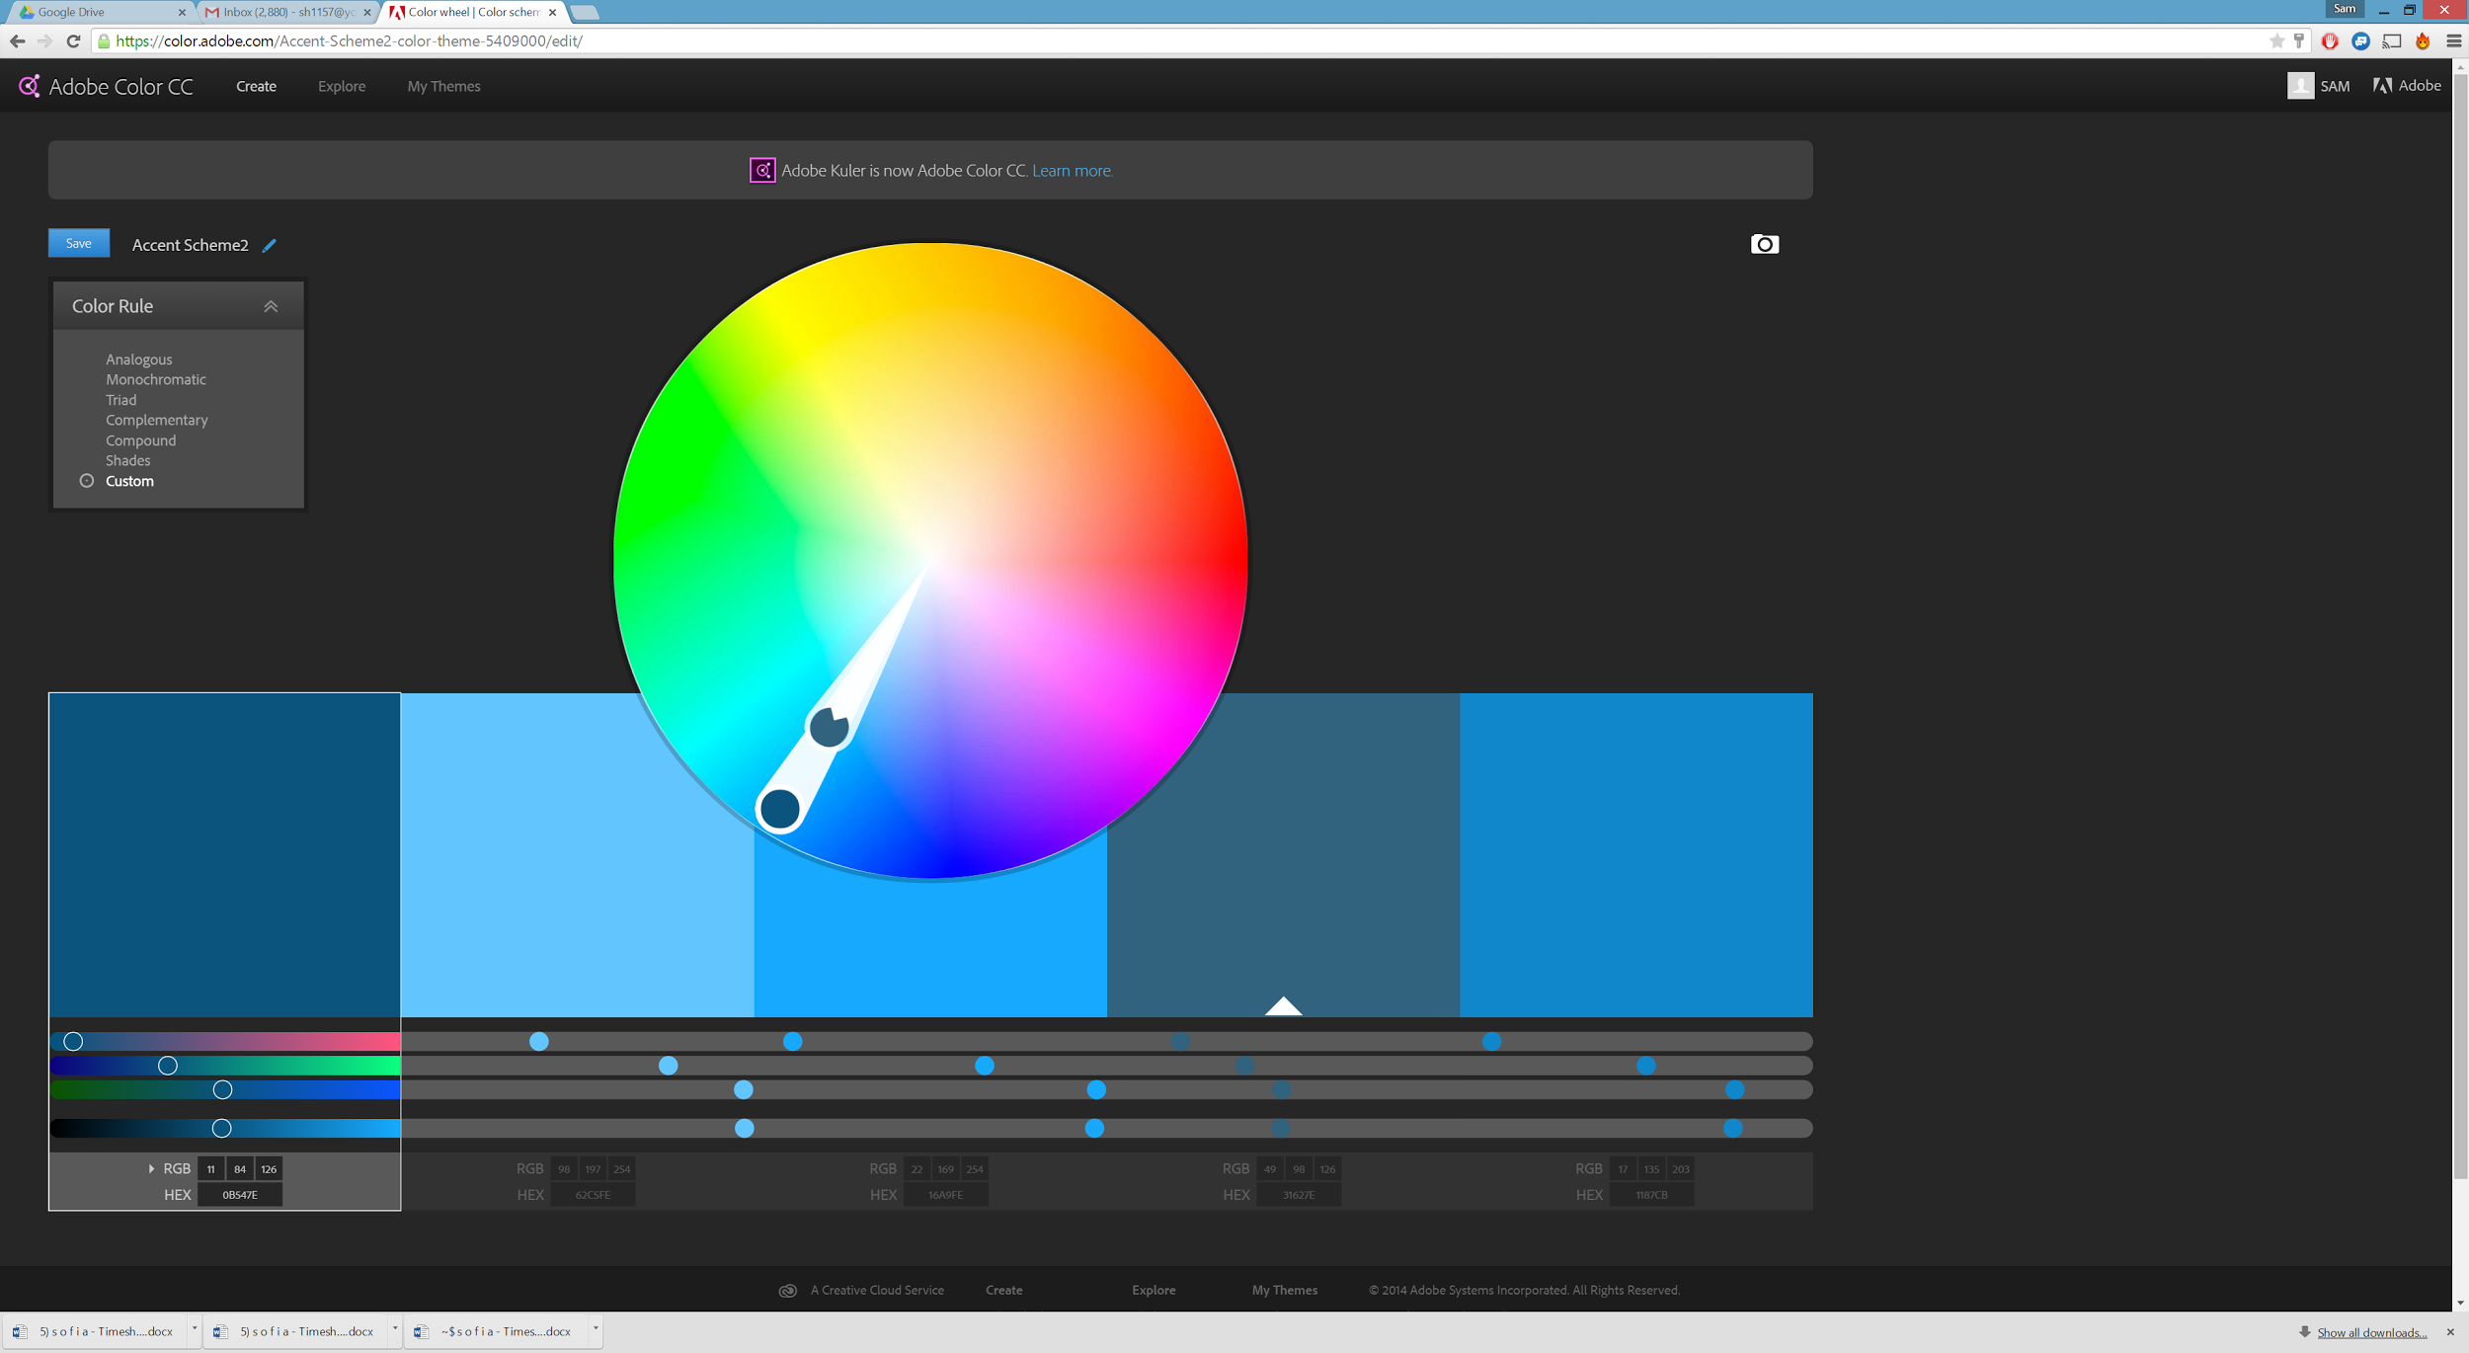

## Icons

Our icons will be created using a design language inspired by Google’s Material design.

The icons will be simple and convey the meaning of the button using simple imagery that the user will be able to understand at a glance. All major icon shapes should be based upon this keyline. All logos should be made to a standard 24 * 24 pixel grid.It may be easier to design using a larger grid and then scale down i.e. Designing in a 192 * 192 grid but remembering that each pixel will effectively be 4 * 4.

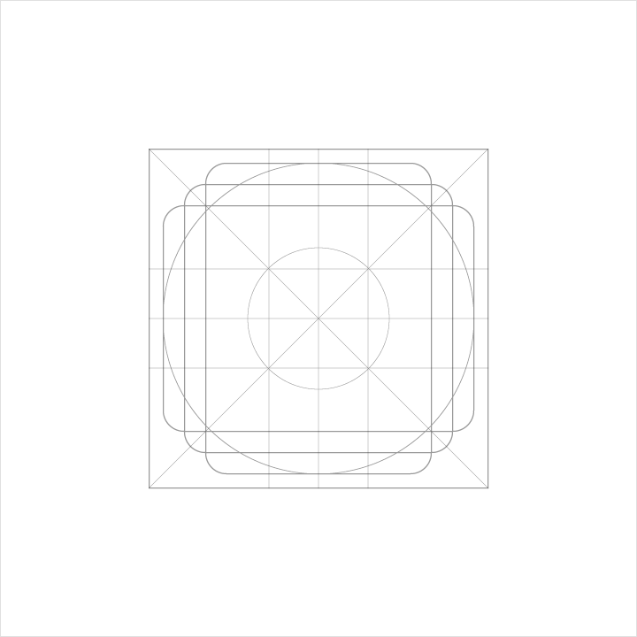

All squares and circles should have a consistent height and radius.

For simple iconography the following templates can be used.

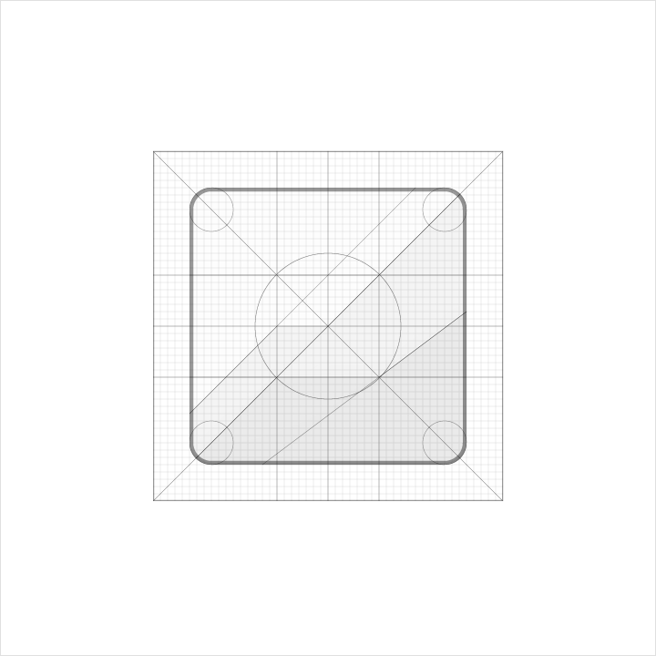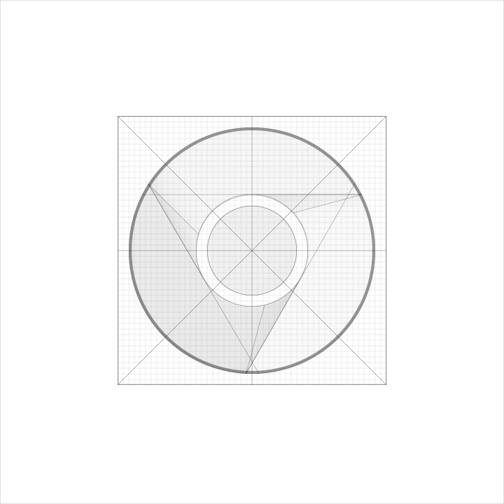

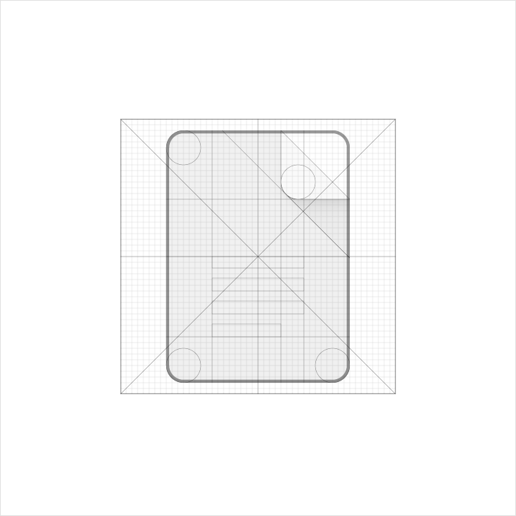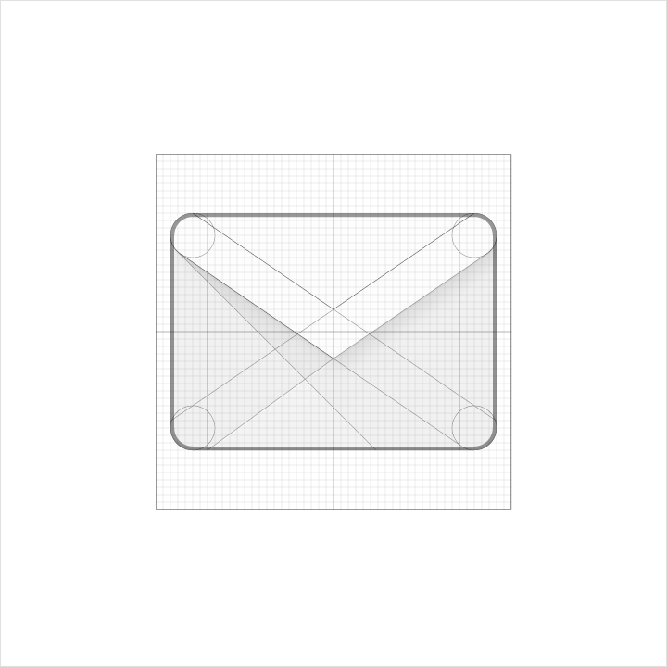

*All the following pixel measurements assume a 24*24 scaled grid is used*

Drop Shadow should be of opacity 20% and offset 6 pixels on the y axis. Blur should be set to 6 pixels.

To provide a sense of depth edge tint and shade can be applied. In all cases where tint and shade are used they have a height of 1 pixels and an opacity of 20%.

The tint should be coloured white mixed with the base colour and only applied to the top edge.

The shade should be coloured black mixed with the base colour and only applied to the bottom edge.

**Icon Rules**

* If an element is coloured (i.e already accented compared to the backdrop) do not embellish with shadow.
* Never exceed more than two layers within one icon
* Dog ears for paper based icons should be dog eared to the top right
* Any elevated layer must remain on top of the layer it is above (i.e. do not crop elevated layers)
* If a shape is scored, score from the center and do not score multiple times
* Do not fold
* If overlaps are used, only overlap once
* If an accordion style icon is created, only use one fold.
* Do not distort or tilt icons
* Icons should leave 4 pixels of trim outside the icon. This area can be used for additional visual weight if necessary
* Any corners should have a 2 pixel radius on the outside. Do not use rounded corners on interior shapes.
* Stroke size should remain consistent, with a standard 2 pixel width.
* When a stroke terminates it should be squared off
* If an extreme scenario calls for a change in these rules, ensure that the root philosophy of simple and obvious icons continues to be obeyed.
* By standard, the opacity of an active icon on a light background is 54% and an inactive icon 26%. For a dark background active icons should have an opacity of 100% and inactive icons 30%.

**Example Icons**

